# VISVESVARAYA TECHNOLOGICAL UNIVERSITY

## BELAGAVI – 590018, Karnataka INTERNSHIP REPORT

#### ON

“Retro Gaming Site”

## BACHELOR OF ENGINEERING IN

## ELECTRONICS AND COMMUNICATION

***Submitted by:***

Dharshan K

4MH21EC022



Conducted at

**Varcons technologies pvt ltd**



**MAHARAJA INSTITUTE OF TECHNOLOGY MYSORE**

**Department of Electronics and communication Engineering**

Belwadi,Srirangapattana taluk,Mandya-571477

Approved by AICTE,New Delhi |Recognized by Govt. of Karnataka | Affilated to VTU,Belgavi All Programs Accredited by NBA, NAAC New Delhi

# 

**MAHARAJA INSTITUTE OF TECHNOLOGY MYSORE**

**Department of Electronics and communication Engineering**

Belwadi,Srirangapattana taluk,Mandya-571477

Approved by AICTE,New Delhi |Recognized by Govt. of Karnataka | Affilated to VTU,Belgavi All Programs Accredited by NBA, NAAC New Delhi

# 

**CERTIFICATE**

This is to certify that the Internship titled **“Retro gaming site”** carried out by **Mr.Dharshan K,** a bonafide student of Maharaja institute of technology Mysuru, in partial fulfillment for the award of **Bachelor of Engineering**, in **ECE** under Visvesvaraya Technological University, Belagavi, during the year 2022-2023. It is certified that all corrections/suggestions indicated have been incorporated in the report.

The project report has been approved as it satisfies the academic requirements in respect of Internship prescribed for the course Internship / Professional Practice

#### Signature of Guide Signature of HOD Signature of Principal

**External Viva:**

Name of the Examiner Signature with Date

1)

2)

# D E C L A R A T I O N

I,Dharshan K, second year student of ECE, Maharaja Institute of Technology Mysore, declare that the Internship has been successfully completed, in Varcons Technologies Pvt Ltd. This report is submitted in partial fulfillment of the requirements for award of Bachelor Degree in ISE, during the academic year 2022-2023.

Date:

Place:

USN: 4MH21EC022

NAME: Dharshan K

**OFFER LETTER PROVIDED BY THE COMPANY**



# A C K N O W L E D G E M E N T

This Internship is a result of accumulated guidance, direction, and support of several important persons. We take this opportunity to express our gratitude to all who have helped us to complete the Internship.

We express our sincere thanks to our Principal, for providing us adequate facilities to undertake this Internship.

We would like to thank our Head of Department of Computer Science, for providing us an opportunity to carry out Internship and for his valuable guidance and support.

We would like to thank our Lab assistant from Varcons Software Services for guiding us during the period of internship.

We express our deep and profound gratitude to our guide, Guide name, Assistant/Associate Prof, for her keen interest and encouragement at every step in completing the Internship.

We would like to thank all the faculty members of our department for the support extended during Internship.

We would like to thank the non-teaching members of our dept, for helping us during the Internship.

Last but not the least, we would like to thank our parents and friends without whose constant help, the completion of Internship would have not been possible.

**NAME: Dharshan K**

**USN: 4MH21EC022**

# ABSTRACT

Based on the analysis of 190 studies (18,573 participants), we estimate that the average silent reading rate for adults in English is 238 words per minute (wpm) for non-fiction and 260 wpm for fiction. The difference can be predicted by taking into account the length of the words, with longer words in non-fiction than in fiction. The estimates are lower than the numbers often cited in scientific and popular writings. The reasons for the overestimates are reviewed. The average oral reading rate (based on 77 studies and 5,965 participants) is 183 wpm. Reading rates are lower for children, old adults, and readers with English as second language. The reading rates are in line with maximum listening speed and do not require the assumption of reading-specific language processing. Within each group/task there are reliable individual differences, which are not yet fully understood. For silent reading of English non-fiction most adults fall in the range of 175 to 300 wpm; for fiction the range is 200 to 320 wpm. Reading rates in other languages can be predicted reasonably well by considering the number of words these languages require to convey the same message as in English.

# Table of Contents

|  |  |  |
| --- | --- | --- |
| **Sl no** | **Description** | **Page no** |
| 1 | Company Profile | 9 |
| 2 | About the Company | 11 |
| [3](https://1.bp.blogspot.com/-dODuK8N5h1Q/Wlnyb3V9HFI/AAAAAAAACL4/WxQtCJ1pM5wccDABg4wIrTBUB0vlikXQQCLcBGAs/s1600/poly1.jpg) | Introduction | 15 |
| [4](https://1.bp.blogspot.com/-dODuK8N5h1Q/Wlnyb3V9HFI/AAAAAAAACL4/WxQtCJ1pM5wccDABg4wIrTBUB0vlikXQQCLcBGAs/s1600/poly1.jpg) | System Analysis | 18 |
| [5](https://1.bp.blogspot.com/-dODuK8N5h1Q/Wlnyb3V9HFI/AAAAAAAACL4/WxQtCJ1pM5wccDABg4wIrTBUB0vlikXQQCLcBGAs/s1600/poly1.jpg) | Requirement Analysis | 20 |
| 6 | Design [Analysis](https://4.bp.blogspot.com/-IOOxgPaXMVc/Wlj3LWvcnjI/AAAAAAAACKE/UeTFYvAxDmUDel5UBjdifeWaApB3-dXVgCLcBGAs/s1600/img1.jpg) | 23 |
| 7 | [Implementation](https://4.bp.blogspot.com/-IOOxgPaXMVc/Wlj3LWvcnjI/AAAAAAAACKE/UeTFYvAxDmUDel5UBjdifeWaApB3-dXVgCLcBGAs/s1600/img1.jpg) | 25 |
| 8 | Snapshots | 27 |
| 9 | Conclusion | 32 |
| 10 | References | 34 |

[**CHAPTER**](https://1.bp.blogspot.com/-dODuK8N5h1Q/Wlnyb3V9HFI/AAAAAAAACL4/WxQtCJ1pM5wccDABg4wIrTBUB0vlikXQQCLcBGAs/s1600/poly1.jpg) **1** **COMPANY PROFILE**

# COMPANY PROFILE

## A Brief History of Varcons Technologies

Varcons Innovations was consolidated with an objective" To give excellent and ideal Mechanical Answers for business necessities of our clients". Each business is an alternate and has an interesting plan of action as are the mechanical prerequisites. They comprehend this and thus the arrangements given to these prerequisites are different also. They center around clients' necessities and give them tailor-made mechanical arrangements. They additionally comprehend that the Compass of their Item to its designated market or the computerization of the current interaction into an e-client and straightforward cycle are the key highlights that our clients want from Innovative Arrangement they are searching for and these are the highlights that we center around while planning the answers for their clients.

Varcons Programming Administrations. is an Innovation Association giving answers for all website composition and improvement, MYSQL, PYTHON Programming, HTML, CSS, ASP.NET, and LINQ. Meeting the always expanding mechanization necessities, Varcons Programming Administrations. have some expertise in ERP, Network, Search engine optimization Administrations, Meeting The executives, compelling web advancement and customized programming items, and planning arrangements best fitting client's prerequisites.

Varcons Advancements, endeavor to be the leader in imagination and development in programming improvement through their well-informed ability and lay out it as an out of the crate programming improvement organization in Bangalore, India. As a product improvement organization, they decipher this product advancement mastery into an incentive for their clients through their expert arrangements.

They comprehend that all that ideal result can be accomplished simply by understanding the client's request better. Varcons Innovations work with its clients and assist them with characterizing their definite arrangement necessity. In some cases, even they wonder if they have totally reclassified their answer or new application necessity during the meeting to generate new ideas, and here they position themselves as an IT arrangements counseling bunch containing superior grade advisors.

They accept that Innovation when utilized appropriately can assist any business with scaling and making new levels of progress. It works on its effectiveness, productivity, and dependability; to place it in one sentence" Innovation assists you with Charming your clients" and that is the very thing we need to accomplish.

# [CHAPTER](https://1.bp.blogspot.com/-dODuK8N5h1Q/Wlnyb3V9HFI/AAAAAAAACL4/WxQtCJ1pM5wccDABg4wIrTBUB0vlikXQQCLcBGAs/s1600/poly1.jpg) 2 ABOUT THE COMPANY

1. **ABOUT THE COMPANY**



Varcons Innovations is an Innovation Association giving answers for all website composition and improvement, MYSQL, PYTHON Programming, HTML, CSS, ASP.NET, and LINQ. Meeting the steadily expanding robotization necessities, Varcons Advances have practical experience in ERP, Availability, Search engine optimization Administrations, Gathering The executives, viable web advancement and customized programming items, and planning arrangements best fitting client's prerequisites. The association where they have the right blend of experts as a partner to assist us with serving our clients to the best of our capacity and with standard industry guidelines. They have youthful, excited, energetic, and imaginative Experts to foster mechanical advancements in the field of Versatile advancements, Web applications as well as Business and Endeavor arrangements. Saying of our association is to "Team up with our clients to give them best Mechanical arrangement subsequently making Great Present and Better Future for our client which will get a flowing a constructive outcome their business shape too". Giving a Total set-up of specialized arrangements isn't simply our slogan, it is Our Vision for Our Clients and as far as we might be concerned, we endeavor hard to accomplish it.

## Products of Varcons Technologies.

**Android Apps**

It is the cycle by which new applications are made for gadgets running the Android working framework. Applications are generally evolved in Java (and additionally Kotlin; or other such choices) programming language utilizing the Android programming improvement pack (SDK), however, other advancement conditions are likewise accessible, whatever as Kotlin support precisely the same Android APIs (and bytecode), while others, for example, Go have limited Programming interface access.

The Android programming improvement unit incorporates a thorough arrangement of improvement instruments. These incorporate a debugger, libraries, a handset emulator in view of QEMU, documentation, test code, and instructional exercises. At present upheld improvement stages incorporate PCs running Linux (any advanced work area Linux circulation), Macintosh operating system X 10.5.8 or later, and Windows 7 or later. As of Walk 2015, the SDK isn't accessible on Android itself, yet programming improvement is conceivable by utilizing particular Android applications.

**Web Application**

It is a client–server computer program in which the client (including the user interface and client- side logic) runs in a web browser. Common web applications include web mail, online

retail sales, online auctions, wikis, instant messaging services and many other functions. web applications use web documents written in a standard format such as HTML and JavaScript, which are supported by a variety of web browsers. Web applications can be considered as a specific variant of client–server software where the client software is downloaded to the client machine when visiting the relevant web page, using standard procedures such as HTTP. The Client web software updates may happen each time the web page is visited. During the session, the web browser interprets and displays the pages, and acts as the universal client for any web application. The use of web application frameworks can often reduce the number of errors in a program, both by making the code simpler, and by allowing one team to concentrate on the framework while another focuses on a specified use case. In applications which are exposed to constant hacking attempts on the Internet, security- related problems can be caused by errors in the program.

Frameworks can also promote the use of best practices such as GET after POST. There are some who view a web application as a two-tier architecture. This can be a “smart” client that performs all the work and queries a “dumb” server, or a “dumb” client that relies on a “smart” server. The client would handle the presentation tier, the server would have the database (storage tier), and the business logic (application tier) would be on one of them or on both. While this increases the scalability of the applications and separates the display and the database, it still doesn’t allow for true specialization of layers, so most applications will outgrow this model. An emerging strategy for application software companies is to provide web access to software previously distributed as local applications. Depending on the type of application, it may require the development of an entirely different browser-based interface, or merely adapting an existing application to use different presentation technology. These programs allow the user to pay a monthly or yearly fee for use of a software application without having to install it on a local hard drive. A company which follows this strategy is known as an application service provider (ASP), and ASPs are currently receiving much attention in the software industry.

Security breaches on these kinds of applications are a major concern because it can involve both enterprise information and private customer data. Protecting these assets is an important part of any web application and there are some key operational areas that must be included in the development process. This includes processes for authentication, authorization, asset handling, input, and logging and auditing. Building security into the applications from the beginning can be more effective and less disruptive in the long run.

**Web design**

It is encompassing many different skills and disciplines in the production and maintenance of websites. The different areas of web design include web graphic design; interface design; authoring, including standardized code and proprietary software; user experience design; and

search engine optimization. The term web design is normally used to describe the design process relating to the front-end (client side) design of a website including writing mark up. Web design partially overlaps web engineering in the broader scope of web development. Web designers are expected to have an awareness of usability and if their role involves creating markup then they are also expected to be up to date with web accessibility guidelines. Web design partially overlaps web engineering in the broader scope of web development.

## Departments and services offered

Varcons Advances assumes a fundamental part as an establishment, the degree of instruction, and improvement of understudy's abilities depends on their mentors. On the off chance that you don't have a decent guide then you might slack in numerous things from others and for that reason, we at Varcons Advancements provide you with the office of talented representatives so you don't have an unstable outlook on the scholastics. Character improvement and scholarly status are a portion of those things which lie in the tutor's hands. If you are prepared well, you can do well in your future, and knowing the significance of Varcons Advancements generally attempts to give you the best.

They have an extraordinary group of talented guides who are dependably prepared to coordinate their students in the most ideal manner they can and to guarantee the abilities of tutors we held numerous expertise improvement programs too so every single coach can foster their own abilities with the requests of the organizations so they can set up a total bundled learner.

## Services provided by Varcons Technologies.

* Core Java and Advanced Java
* Web services and development
* Dot Net Framework
* Python
* Selenium Testing
* Conference / Event Management Service
* Academic Project Guidance
* On The Job Training
* Software Training

# [CHAPTER](https://1.bp.blogspot.com/-dODuK8N5h1Q/Wlnyb3V9HFI/AAAAAAAACL4/WxQtCJ1pM5wccDABg4wIrTBUB0vlikXQQCLcBGAs/s1600/poly1.jpg) 3 INTRODUCTION

1. **INTRODUCTION**

* Retro gaming

A retro game refers to a video game that was developed and released during the early years of the gaming industry, typically from the 1970s to the 1990s. These games are characterized by their simplistic graphics and sound, limited processing power, and often feature 2D gameplay. Retro games were played on various platforms such as arcade machines, home consoles (e.g., Atari, Nintendo Entertainment System), and personal computers.

Retro games hold a special nostalgic value for many gamers who grew up during that era. They are known for their challenging gameplay, addictive mechanics, and the creativity of game developers who worked with limited resources. Classic games like Pac-Man, Super Mario Bros., Space Invaders, and Tetris are examples of iconic retro games that have had a lasting impact on the gaming industry.

Today, retro games continue to have a dedicated fanbase, and many modern games pay homage to their retro counterparts by incorporating similar visual styles, gameplay mechanics, or sound effects. Additionally, retro games are often re-released or emulated on modern platforms, allowing new generations of players to experience the charm and nostalgia of these classic titles.

* A brief introduction about classic snake game

The retro classic snake game is a timeless and iconic video game that gained popularity in the

late 1970s and early 1980s. It originated from early arcade machines and was later adapted for

various home gaming systems, such as the Nokia mobile phones in the late 1990s.

In the snake game, players control a snake-like creature that moves around a rectangular grid or maze. The objective is to guide the snake to eat food items, which causes the snake to grow longer. The challenge lies in avoiding collisions with the walls or the snake's own body. As the snake grows, it becomes increasingly difficult to navigate the playing area without hitting obstacles.

The controls are typically simple, with players using arrow keys or directional buttons to steer the snake in different directions. The game's mechanics are easy to understand, making it accessible to players of all ages.

The snake game's appeal lies in its addictive nature and the pursuit of high scores. Players aim to eat as much food as possible to increase their score while trying to outlast their previous attempts. The game's simplicity, combined with its competitive nature, has made it a beloved classic across generations.

Despite its humble origins, the snake game has evolved and adapted to modern platforms. It can now be found as a pre-installed game on many smartphones and is available as a downloadable app or browser-based game. Various iterations and adaptations of the game have also been created, adding new features, graphics, and challenges while still maintaining the core gameplay mechanics.

The snake game's enduring popularity is a testament to its timeless appeal and the nostalgia it evokes among players. It serves as a reminder of the early days of video gaming and continues to entertain and captivate players today.

# [CHAPTER](https://1.bp.blogspot.com/-dODuK8N5h1Q/Wlnyb3V9HFI/AAAAAAAACL4/WxQtCJ1pM5wccDABg4wIrTBUB0vlikXQQCLcBGAs/s1600/poly1.jpg) 4 SYSTEM ANALYSIS

**4. SYSTEM ANALYSIS**

1.User Interface (UI): The UI presents the game to the player and typically includes the game area (grid or maze), the snake, food items, score display, and any additional information or menus. It allows the player to interact with the game through input devices like keyboards or controllers.

2.Game Logic: The game logic manages the rules and mechanics of the snake game. It includes functions for controlling the snake's movement, detecting collisions with walls, obstacles, or the snake's body, generating food items, updating the score, and managing the game's state (start, pause, game over).

3.Snake Control: The snake control component receives input from the player, such as arrow key presses or directional buttons, to determine the direction the snake should move. It ensures that the snake can only move in valid directions and updates its position accordingly.

4.Collision Detection: This component checks for collisions between the snake and various game elements. It detects collisions with walls, obstacles, the snake's own body, and food items. When a collision occurs, it triggers the appropriate actions, such as game over or increasing the snake's length.

5.Score Management: The score management component keeps track of the player's score throughout the game. It increments the score when the snake eats food items and updates the score display in the UI.

6.Random Food Generation: This component generates food items at random positions within the game area. It ensures that the food does not appear on walls, obstacles, or the snake's body. The food serves as a target for the snake to eat and grow.

7.Game State Management: The game state management component handles the game's state transitions, including starting a new game, pausing or resuming gameplay, and determining when the game is over. It also manages high scores and any necessary data storage.

8.Graphics and Audio: The graphics and audio components handle the visual and auditory aspects of the game. They render the game elements, such as the snake, food items, and background, and provide sound effects or background music to enhance the player's experience.

9.Input Handling: The input handling component receives input from the player through input devices and translates it into commands for controlling the snake's movement. It ensures that the game responds accurately and promptly to player actions.

10.Platform Compatibility: Classic snake games have been implemented on various platforms, such as arcade machines, early home gaming systems, and modern devices like smartphones and computers. The system analysis includes considerations for platform-specific requirements, such as screen resolutions, input methods, and performance optimizations.

System analysis helps developers understand the structure and interactions of the components within the snake game, enabling them to design, implement, and maintain a functional and enjoyable gaming experience for the players

In the existing system the exams are done only manually but in proposed system

we have to computerize the exams using this ap

# [CHAPTER](https://1.bp.blogspot.com/-dODuK8N5h1Q/Wlnyb3V9HFI/AAAAAAAACL4/WxQtCJ1pM5wccDABg4wIrTBUB0vlikXQQCLcBGAs/s1600/poly1.jpg) 5 REQUIREMENT ANALYSIS

**5. REQUIREMENT ANALYSIS**

Requirement analysis for a classic snake game involves identifying and specifying the functional and non-functional requirements of the system. Here are some detailed requirements for a classic snake game:

Functional Requirements:

1.Game Start: The player should be able to start a new game at any time.

2.Snake Movement: The snake should move in the direction specified by the player's input.

3.Grid or Maze: The game should provide a grid or maze-like playing area for the snake to navigate.

4.Food Generation: The game should generate food items at random positions within the playing area.

5.Snake Growth: When the snake eats a food item, it should grow in length.

6.Collision Detection: The game should detect collisions between the snake and walls, obstacles, or its own body.

7.Scoring: The game should track the player's score based on the number of food items eaten.

8.Game Over: The game should end and display the final score when the snake collides with a wall, obstacle, or its own body.

9.High Scores: The game should record and display the highest scores achieved by players.

10.Pause/Resume: The player should be able to pause and resume the game at any point.

Non-functional Requirements:

1.User Interface: The game's UI should be intuitive, visually appealing, and easy to navigate.

2.Responsiveness: The game should respond promptly to user input, providing smooth and seamless gameplay.

3.Performance: The game should run smoothly without significant lags or delays.

4.Compatibility: The game should be compatible with different platforms, devices, and screen resolutions.

5.Sound Effects: The game should have optional sound effects to enhance the gaming experience.

6.Scalability: The game should be able to handle an increasing number of food items and a growing snake without performance degradation.

7.Portability: The game should be portable, allowing easy deployment on various platforms and devices.

8.Accessibility: The game should be accessible to players with disabilities, providing necessary options for visual or auditory impairments.

9.Localization: The game should support multiple languages or provide options for localization.

10.Error Handling: The game should handle errors gracefully, displaying appropriate error messages and allowing the player to recover from unexpected situations.

These requirements serve as a basis for designing and developing a classic snake game that meets the expectations of players while ensuring a smooth and enjoyable gaming experience..

# [CHAPTER](https://1.bp.blogspot.com/-dODuK8N5h1Q/Wlnyb3V9HFI/AAAAAAAACL4/WxQtCJ1pM5wccDABg4wIrTBUB0vlikXQQCLcBGAs/s1600/poly1.jpg) 6 DESIGN ANALYSIS

1. **DESIGN & ANALYSIS**

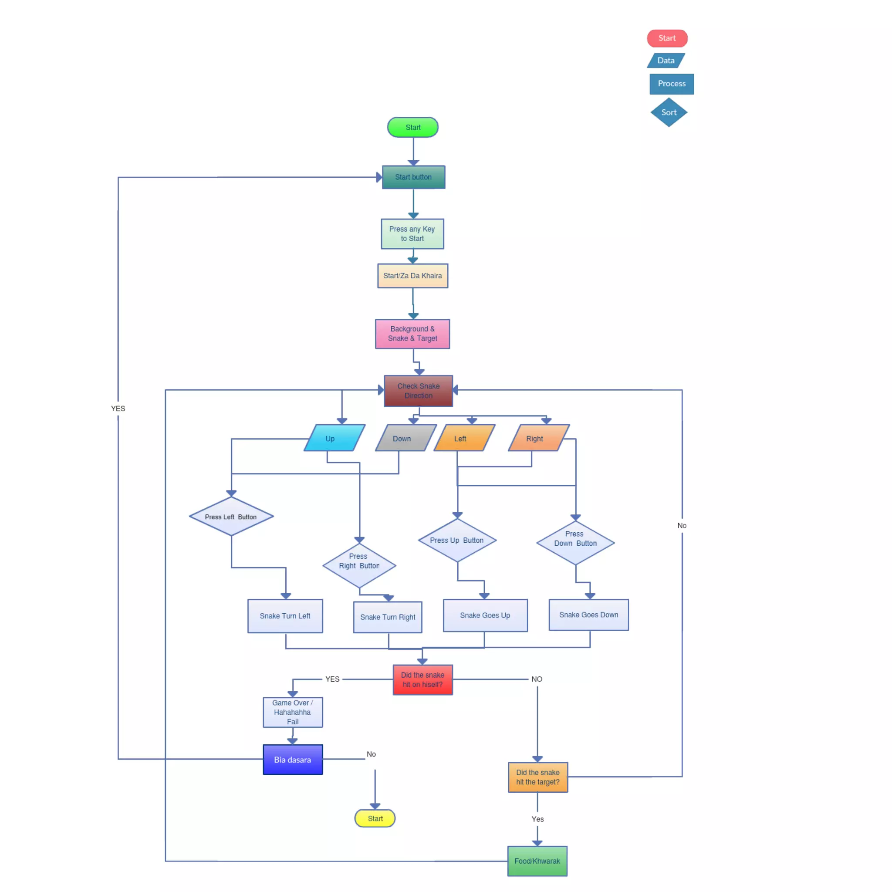

# [CHAPTE](https://1.bp.blogspot.com/-dODuK8N5h1Q/Wlnyb3V9HFI/AAAAAAAACL4/WxQtCJ1pM5wccDABg4wIrTBUB0vlikXQQCLcBGAs/s1600/poly1.jpg)R 7 IMPLEMENTATION

1. **IMPLEMENTATION**

## 

Set up the game window using a graphics library like Pygame.

Define necessary variables such as window dimensions, colors, and cell size.

Create a Snake class with attributes like size, body (a list of segments), and direction (dx and dy).

Implement methods in the Snake class:

move() to update the snake's position by adding a new head segment and removing the tail if necessary.

change_direction(dx, dy) to update the direction of the snake while preventing reversing direction.

check_collision() to detect collisions with walls or the snake's own body.

draw() to render the snake's body on the game window.

Create a Food class with attributes like x and y coordinates.

Implement methods in the Food class:

generate() to randomly generate new coordinates for the food.

draw() to render the food on the game window.

Set up the game loop:

Handle events like quitting the game or changing the snake's direction based on user input.

Move the snake by calling its move() method.

Check for collision with the food and update the snake's size accordingly.

Render the snake and food on the game window by calling their respective draw() methods.

Update the display to show the changes on the screen.

Limit the game's speed by using a clock object from the graphics library.

Run the game loop until the player quits the game.

Add any additional features like scoring, game over conditions, or high scores as desired.

Clean up and quit the game.outcomes when running all in all.

# [CHAPTE](https://1.bp.blogspot.com/-dODuK8N5h1Q/Wlnyb3V9HFI/AAAAAAAACL4/WxQtCJ1pM5wccDABg4wIrTBUB0vlikXQQCLcBGAs/s1600/poly1.jpg)R 8 SNAPSHOTS

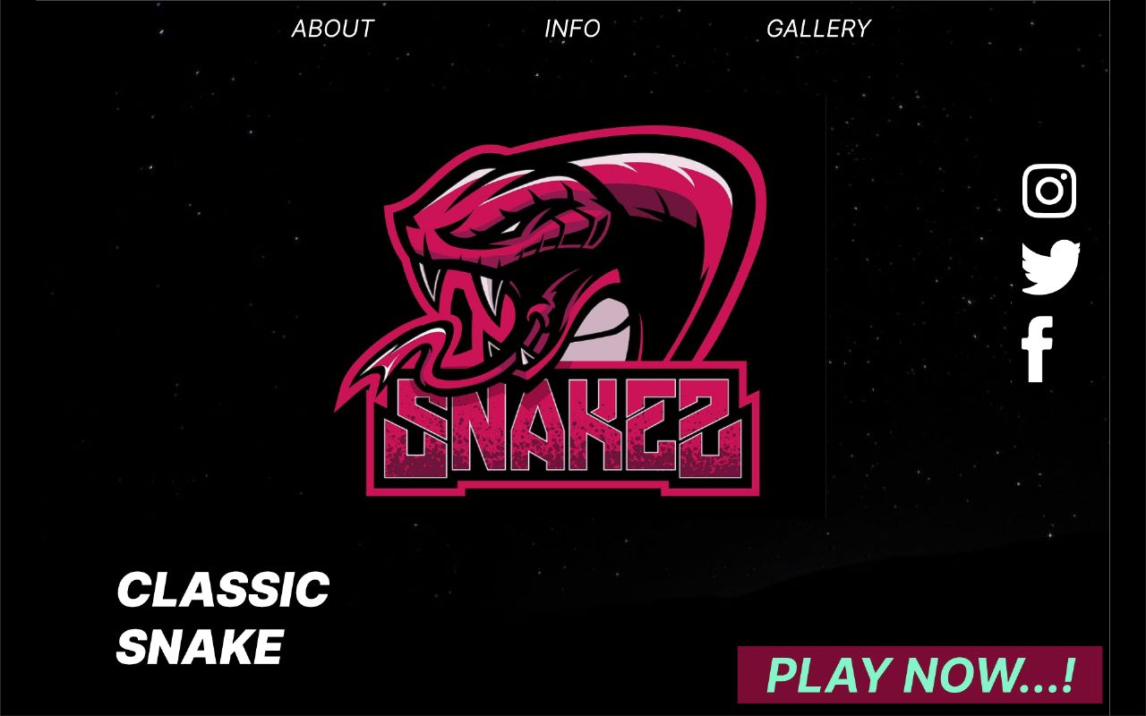

**Figure : Home page**

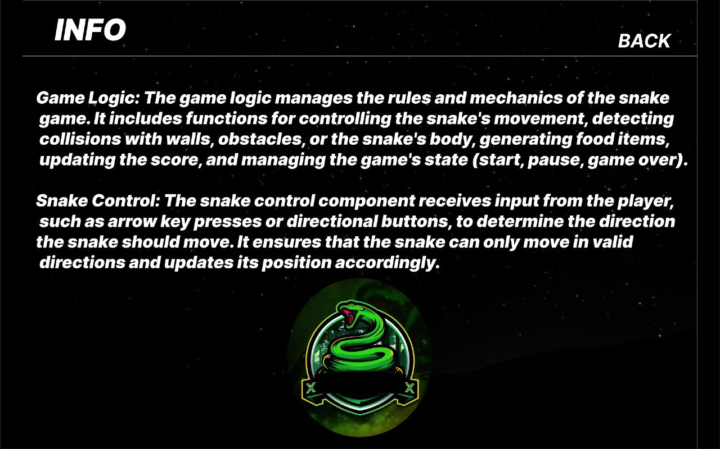

**Figure :Info Page**

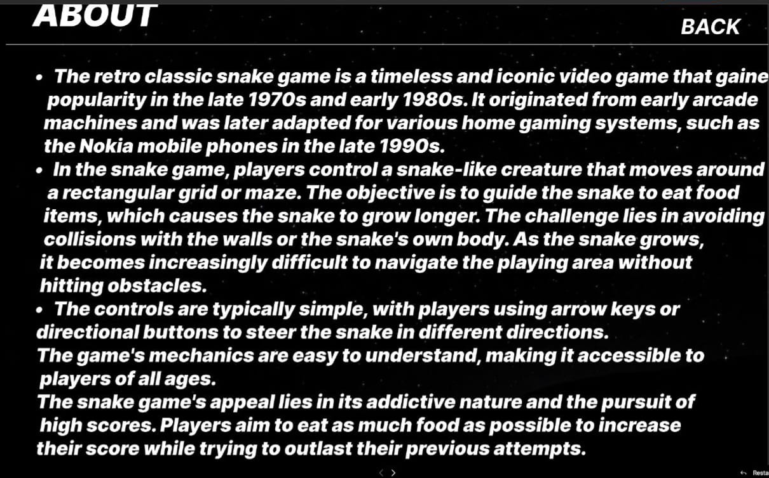

**Figure :About Page**

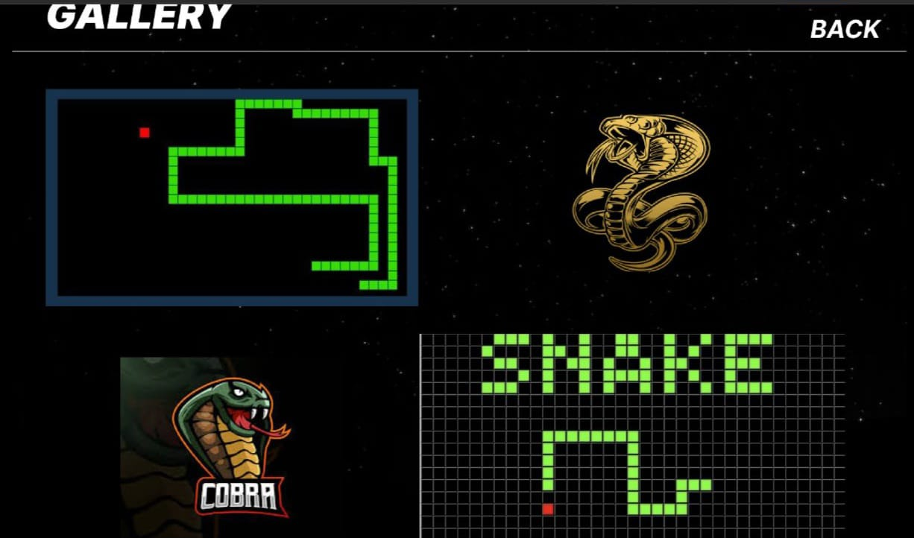

**Figure :Gallery Page**

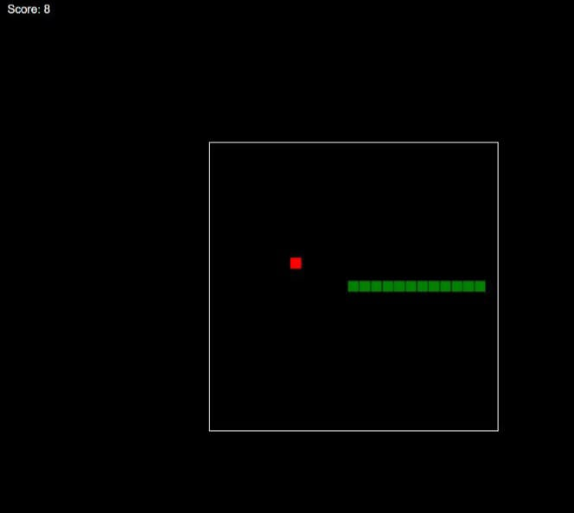

**Figure : Gaming (Code executed)**

# [CHAPTE](https://1.bp.blogspot.com/-dODuK8N5h1Q/Wlnyb3V9HFI/AAAAAAAACL4/WxQtCJ1pM5wccDABg4wIrTBUB0vlikXQQCLcBGAs/s1600/poly1.jpg)R-9.

# CONCLUSION

**9.CONCLUTION**

* In conclusion, the classic Snake retro game holds a special place in the hearts of many gamers and continues to captivate players even today. Originally introduced in the late 1970s and popularized in the 1990s through early mobile phones, the game has become an icon of simplicity and addictive gameplay.
* Snake revolves around controlling a growing snake-like creature on a grid-based arena, aiming to eat food and avoid colliding with the snake's own tail or the boundaries of the play area. As the snake consumes more food, it grows longer, making it increasingly challenging to navigate without self-collision.
* The game's appeal lies in its straightforward mechanics, intuitive controls, and escalating difficulty. The pursuit of achieving a high score and surpassing previous achievements has fueled countless hours of entertainment. Snake also encourages strategic thinking, reflexes, and pattern recognition, testing players' abilities to plan their moves and react swiftly.
* Over time, Snake has evolved and adapted to different platforms and technologies, appearing on various gaming consoles, computers, and smartphones. It has been reimagined with enhanced graphics, new features, and multiplayer options, while still retaining its original essence.
* Beyond its entertainment value, Snake has influenced the gaming industry and inspired the creation of numerous similar games and variations. Its fundamental gameplay mechanics have been integrated into other genres, demonstrating the lasting impact and legacy of this simple yet addictive concept.
* In summary, the classic Snake retro game continues to charm players with its timeless appeal, addictive gameplay, and simple yet challenging mechanics. It remains an enduring symbol of the early days of gaming, reminding us of the joy and excitement that can be found in the most straightforward experiences.

**10.REFERENCE**

* <Http://githu.com>
* [chat.openai.com](https://chat.openai.com/chat).
* [www.google.com](http://www.google.com)